Google Maps Datatype for Umbraco

Version 1.1

Copyright © 2009, Ferguson Moriyama Limited. All rights reserved

Introduction 3

Important Information 3

Prerequisites 3

Requirements 3

Downloading 3

Google Maps API key 3

Installation 3

GUI Configuration 4

Default locations 4

Manual configuration 5

Map dimensions 5

Uninstalling 5

Using the Datatype 5

Rendering maps on the front end of your website 5

Using the datatype in the Umbraco GUI 6

Troubleshooting 7

Support 8

Future Versions 8

License 8

# Introduction

The Google Maps Datatype for Umbraco allows you to specify a latitude/longitude point to be saved in an Umbraco document. This point is chosen using a Google map.

# Important Information

The Google Maps Datatype for Umbraco has the following limitations when used with Umbraco Canvas.

The first time that you click on a map location to edit it - in Internet Explorer only - the map doesn't render. Subsequent edits work.

The second issue is that if you edit one map on a canvas page and then edit another map before saving the document then the second map that you edit takes the value of the first.

These limitations are due to issues with Umbraco Canvas which is part of the Umbraco product and not a limitation of this datatype. Ferguson Moriyama is unable to provide a solution to these issues until the underlying issues in the Umbraco core have been addressed.

# Prerequisites

## Requirements

The Google Maps Datatype for Umbraco will work with Umbraco version 4.0.1 or later. Previous versions of Umbraco are not supported.

## Downloading

The Google Maps Datatype for Umbraco for Umbraco can be downloaded from the following URL:

## <http://our.umbraco.org/media/wiki/4859/633821710673640000_Google_Maps_datatype_11.zip>

## Google Maps API key

Before installing The Google Maps Datatype for Umbraco you should obtain a Google Maps API key from the following site:

<http://code.google.com/apis/maps/signup.html>

You will need one API key per domain in which you wish to use the datatype.

# Installation

In the developer section of the Umbraco GUI:

* Expand the packages node of the navigation tree.
* Click on install local package.
* Click on the browse button in the right pane and locate your downloaded version of The Google Maps Datatype for Umbraco.
* Click on the Load Package button.
* Confirm any following steps.

## GUI Configuration

Once the package has been installed the following GUI will be displayed and will allow you to add your Google maps API key to the package configuration:

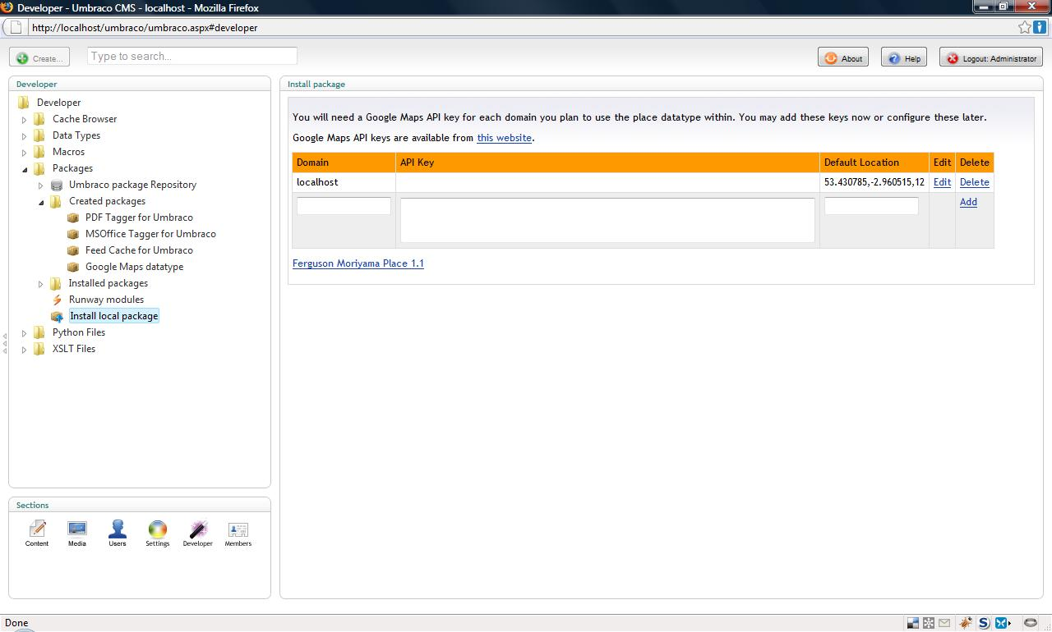

The configuration GUI can be accessed at any time that you are logged in to Umbraco by pointing your browser at:

http://host/umbraco/plugins/FergusonMoriyama/place/Config.aspx

The GUI configuration can also be added to the Umbraco dashboard by adding a reference to the post install user control in the dashboard configuration file. The post install user control is located in:

/umbraco/plugins/FergusonMoriyama/place/FmPlacePostIntall.ascx

The Umbraco dashboard configuration is located in:

/config/Dashboard.config

## Default locations

A default location is displayed when a map has no current location set.

Default locations should be specified in the following format:

<***latitude>,<longitude>,<zoom>***

Zoom is an optional value. Zoom levels are detailed in the [Google maps API documentation](http://code.google.com/apis/maps/documentation/).

## Manual configuration

Google maps API keys can also be manually added to the following XML configuration file (relative to your website document root):

/umbraco/plugins/FergusonMoriyama/place/place.config

The place configuration file looks as follows:

<?xml version="1.0" standalone="yes"?>

<root>

<record>

<domain>localhost</domain>

<api_key>……</api_key>

<default_location>53.430785,-2.960515,12</default_location>

</record>

</root>

A record node should be added for each Google maps API key that you have obtained.

## Map dimensions

Map dimensions can be altered by modifying one or more classes in the following CSS file:

/umbraco/plugins/FergusonMoriyama/place/place.css

By default the datatype renders maps with a width that scales to fit the available area of it’s containing element and a height of 375 pixels. These settings can be modified by changing the properties of the ***.fmpContainer div.map*** class in the CSS file.

## Uninstalling

Delete ***FergusonMoriyama.Place.dll*** from the bin directory of your Umbraco website.

Delete the following folder from your web document root:

/umbraco/plugins/FergusonMoriyama/place

# Using the Datatype

Once installed The Google Maps Datatype for Umbraco needs to be added to one or more Umbraco document types.

Before this can be done you need to create a new Datatype in the Umbraco developer section which has the Rendercontrol value ‘Ferguson Moriyama place’.

A screen cast showing a demonstration of how to use the datatype is available at this URL:

<http://www.darren-ferguson.com/2009/2/16/screencast-umbraco-map-datatype-preview.aspx>

## Rendering maps on the front end of your website

The Google Maps Datatype for Umbraco is used to store latitude/longitude locations in your Umbraco website. It does not provide the ability to render Google maps in your front end website.

A brief tutorial on how to accomplish this is available at this website:

<http://www.darren-ferguson.com/2009/3/14/quick-tip-displaying-maps-on-your-umbraco-website.aspx>

## Using the datatype in the Umbraco GUI

Enter some text in the location search textbox in order to find a location. You can specify the following:

* Postal/Zip Code
* Town
* City
* Street
* Country

Click the ***Look up*** button and one or more location pins will appear if search results are found.

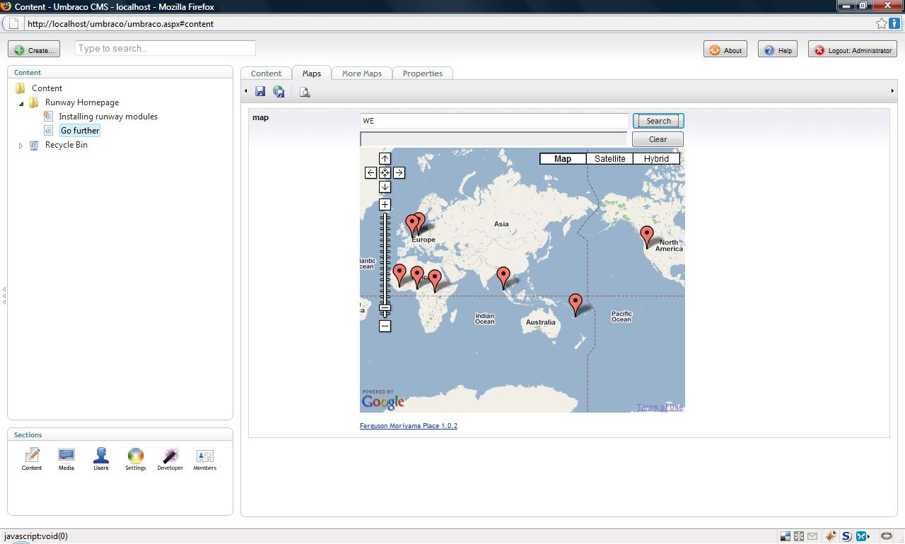

If search results are found then one or more pin will appear on the map.

Click on any pin to view more details about its location:

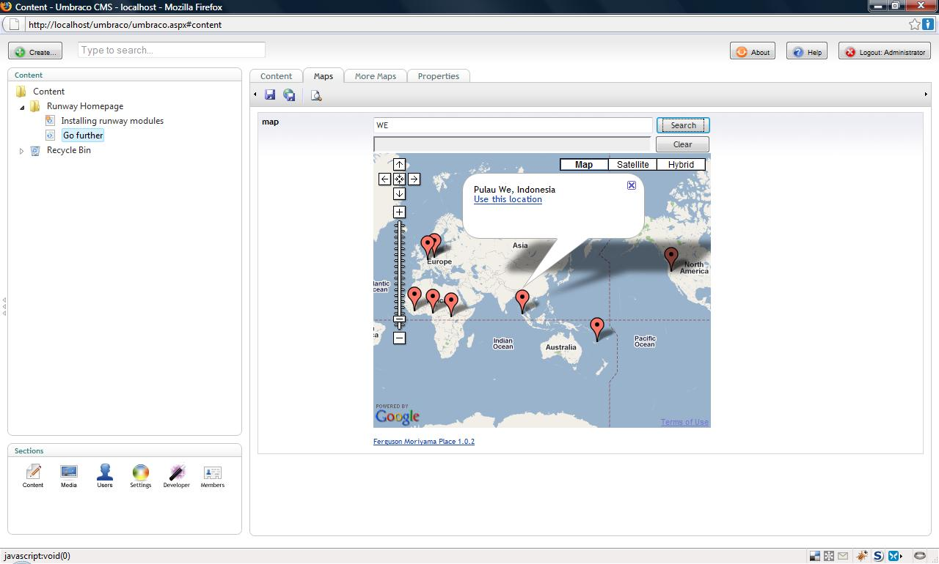

If you are happy with the location of the pin click on the ***Use this location*** link that appears in the speech bubble popup.

You may use the zoom controls on the map to zoom in on clusters of pins on the map.

You may also drag and drop pins if you wish to specify a more precise location.

Once you have specified a location save your Umbraco document as usual. To remove a location click the ***clear*** button below the ***Look up*** button.

# Troubleshooting

Before contacting Ferguson Moriyama for support please verify the following.

* ***FergusonMoriyama.Place.dll*** is in the bin directory of your Umbraco Website
* The following files exist in your Umbraco website:
* /umbraco/plugins/FergusonMoriyama/place/place.js
* /umbraco/plugins/FergusonMoriyama/place/place.config
* /umbraco/plugins/FergusonMoriyama/place/mapProxy.aspx
* /umbraco/plugins/FergusonMoriyama/place/place.css
* /umbraco/plugins/FergusonMoriyama/place/place/FmPlacePostIntall.ascx
* /umbraco/plugins/FergusonMoriyama/place/place/Config.aspx

If any of the files specified above are missing then re-install the Umbraco package as detailed in the Installation section of this document.

# Support

Ferguson Moriyama provides support for MSOffice Tagger for Umbraco via telephone and email.

Telephone support is available from 9am to 5pm GMT Monday to Friday. Support is not available on UK public holidays. In the event that telephone support is unavailable please leave a voicemail.

We aim to respond to support requests within 2 business days, we will normally respond significantly quicker and on rare occasions it may take us longer. Please be sympathetic to time zone differences when contacting us and note we are based in the UK and operate on GMT.

Email: [df@fergusonmoriyama.com](mailto:df@fergusonmoriyama.com)

Telephone: +44 (0)904 194 8721**

Skype: darrenjferguson

* 18+ bill payers only. Calls cost £1.50 per minute, more from mobiles. SP PremTel Help 08709770640.

# Future Versions

Future versions of the datatype will contain the following features.

* Provide cheap commercial version that does not display a Ferguson Moriyama link when rendered in the Umbraco GUI.

# License

The MIT License

Copyright (c) 2009 Ferguson Moriyama

Permission is hereby granted, free of charge, to any person obtaining a copy  
of this software and associated documentation files (the "Software"), to deal  
in the Software without restriction, including without limitation the rights  
to use, copy, modify, merge, publish, distribute, sublicense, and/or sell  
copies of the Software, and to permit persons to whom the Software is  
furnished to do so, subject to the following conditions:

The above copyright notice and this permission notice shall be included in  
all copies or substantial portions of the Software.

THE SOFTWARE IS PROVIDED "AS IS", WITHOUT WARRANTY OF ANY KIND, EXPRESS OR  
IMPLIED, INCLUDING BUT NOT LIMITED TO THE WARRANTIES OF MERCHANTABILITY,  
FITNESS FOR A PARTICULAR PURPOSE AND NONINFRINGEMENT. IN NO EVENT SHALL THE  
AUTHORS OR COPYRIGHT HOLDERS BE LIABLE FOR ANY CLAIM, DAMAGES OR OTHER  
LIABILITY, WHETHER IN AN ACTION OF CONTRACT, TORT OR OTHERWISE, ARISING FROM,  
OUT OF OR IN CONNECTION WITH THE SOFTWARE OR THE USE OR OTHER DEALINGS IN  
THE SOFTWARE.